

School of Computer Science and Engineering
Working Model (Software)

Project Title | Real Time Transcription Service Model
Lab.No | AB3 - 311
Description of Project | This project focuses on developing a real-time audio-to-text transcription system that captures live audio through a microphone and instantly converts it into accurate English text using Whisper AI. The system continuously processes speech as it is recorded, enabling smooth and immediate transcription with high accuracy. Optimized specifically for English audio, it effectively handles different speaking speeds, accents, and background noise. This solution is designed to support live note-taking, lectures, meetings, interviews, and other scenarios where fast and reliable English speech-to-text conversion is essential.  The usage of Open Source software’s and tools makes it reproducible by anyone and leads a foundation towards building a transcription service
Faculty and Student Name | Emp. ID./Reg.No | Faculty Name/ Student Name | Department
Faculty and Student Name | 52825 | Dr.Vatchala S | SCOPE
Faculty and Student Name | 24BCE1102 | Rohit Anil Kumar | SCOPE
Faculty and Student Name | 24BCE1168 | Adithyan P | SCOPE

ALGORITHM
1. The program starts and displays the main menu.
2. The user selects whether to set up the server, load the Whisper model, start transcription, or exit.
3. If the user chooses setup, the program loads any saved configuration from config.json.
4. The program then asks the user to enter the API URL, the room ID, and the Whisper model size.
5. The program validates that the room ID contains exactly six alphanumeric characters.
6. The entered configuration values are saved back into config.json.
7. If the user chooses to load the model, the program detects whether GPU is available.
8. The Whisper model of the chosen size is loaded on the detected device.
9. If the user chooses to start transcribing, three message queues are initialized for audio, processing, and API sending.
10. The program then starts three parallel threads: the audio buffering thread, the processing thread, and the API sender thread.
11. The audio buffering thread opens the microphone input stream at a sample rate of 16,000 Hz.
12. Whenever audio is recorded, it is pushed into the audio queue.
13. The thread continuously collects this audio into a buffer.
14. When the buffer reaches 3 seconds of audio, a chunk is extracted and sent to the processing queue.
15. The processing thread waits for audio chunks from the queue.
16. When a chunk arrives, it is saved temporarily as a WAV file.
17. The Whisper model transcribes this audio file into English text.
18. If the transcribed text is meaningful, it is printed on the screen.
19. The text is then added as a payload to the API queue.

20. The API sender thread waits for payloads in its queue.
21. When a payload is available, it sends the text to the configured API URL along with the room ID.
22. The thread prints whether the API request was successful or if an error occurred.
23. The program continues running until the user presses Ctrl+C or chooses to exit.
24. When exiting, the program signals all threads to stop.
25. Each thread is joined and safely closed.
26. The program then prints a shutdown message and terminates.

RESOURCES
Codebase: https://github.com/LegitCoconut/os_project_real_time_transcription
Website: https://echovault.malabarmatrix.site

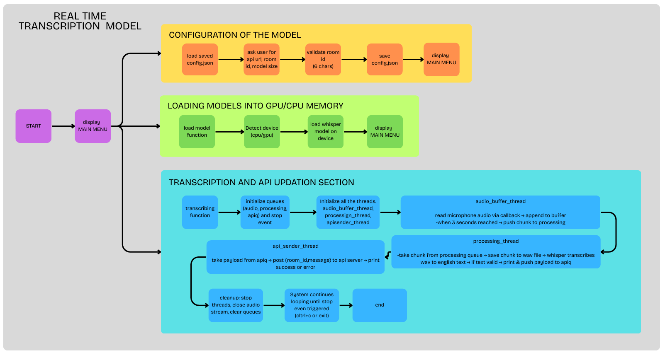
FLOWCHART

RESULT
Homepage:
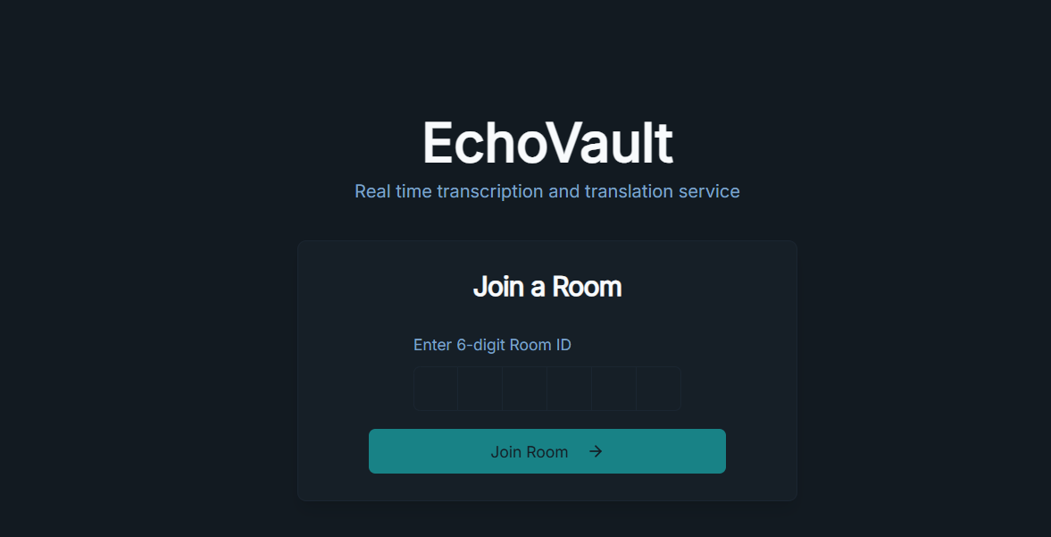
Page For Specific Chats:
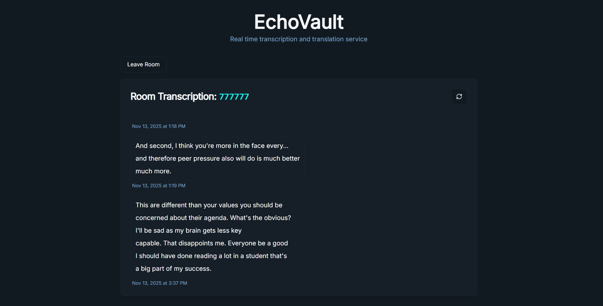
Configuration of API, Room ID and Whisper Model size
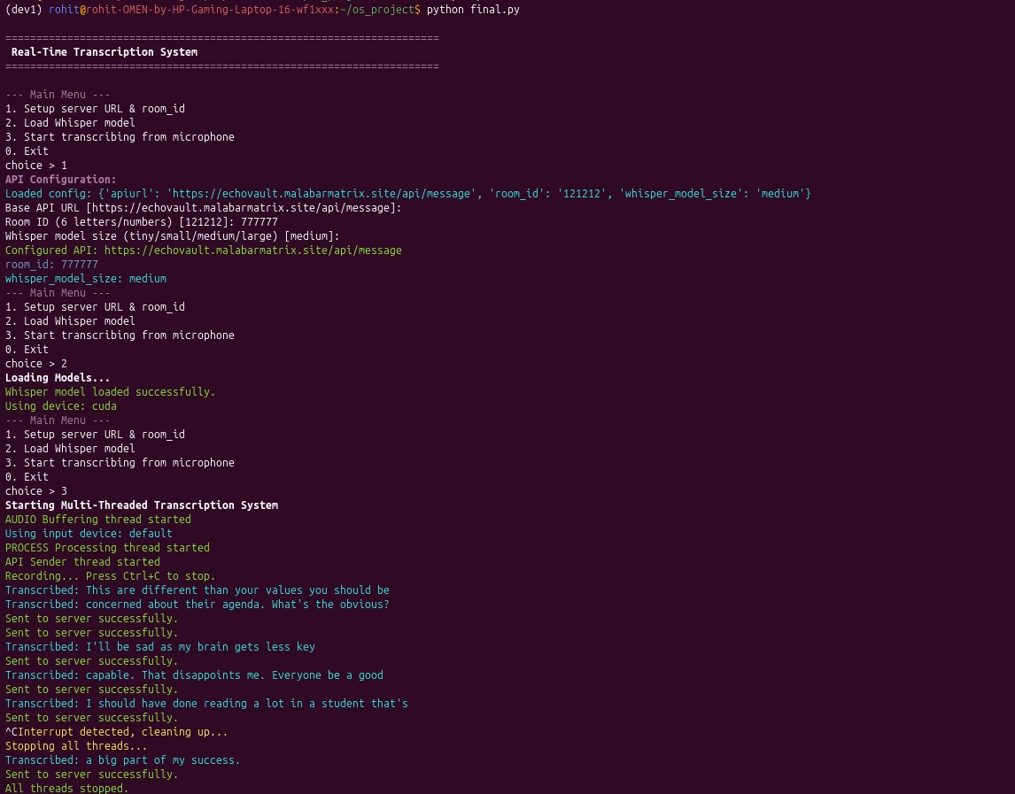

Loading Whisper Model to CPU/GPU memory
Starting Transcribing live audio from microphone and sending to server

PROJECT POSTER
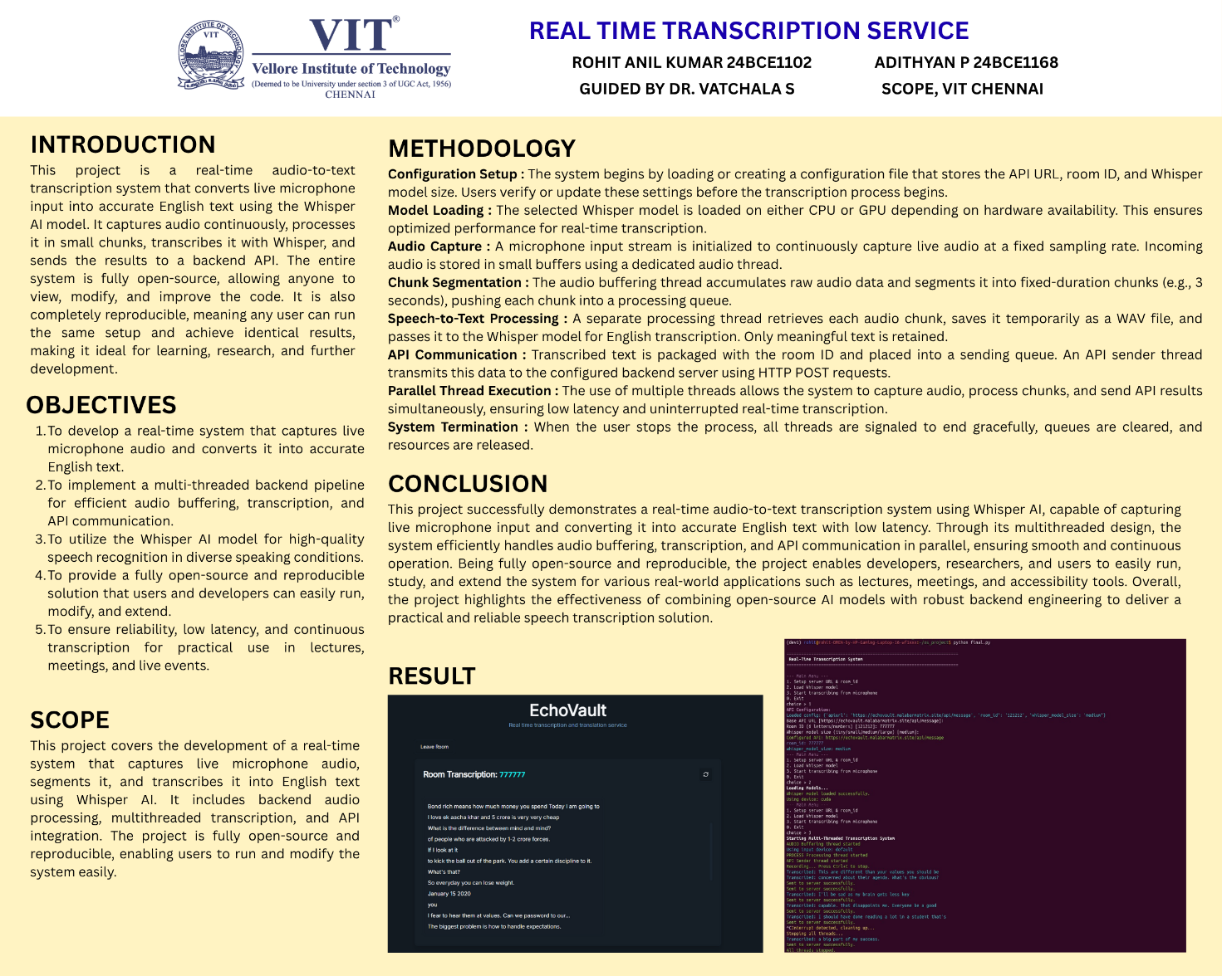

CONCLUSION
This project successfully demonstrates a fully functional real-time speech-to-text system built using open-source tools, modular design principles, and multithreaded processing. Through the integration of Whisper for transcription, Python’s audio processing libraries, and a queue-based thread architecture, the system is able to capture live microphone input, segment it efficiently, transcribe it with high accuracy, and transmit the resulting text to a remote server with minimal latency. The structured workflow—from configuration, live audio capture, and transcription to API communication—ensures both reliability and scalability.
The use of open-source software, libraries, and frameworks plays a central role in the success of this project. Because every major component—from the Whisper model to the audio handling stack—is openly available, the system remains fully reproducible, transparent, and easily extendable. This open ecosystem encourages community involvement, allowing developers to study, modify, improve, and adapt the project to suit a wide range of real-world applications. As a result, the project not only provides a robust technical solution but also contributes to a collaborative and sustainably growing open-source environment.

Signature of the Faculty

